School Of Mechanical & Manufacturing Engineering, NUST

Department of Mechanical Engineering

CS-114 - Fundamental of Programing

Home task # 8

**Course Instructor:** Dr Khwaja Fahad Iqbal

**Lab Instructor:** Muhammad Affan

**Student Name: ZORAIZ ABBAS**

**CMS ID: 454752**

**DATE:**

**6 DEC 2023**

Fundamental of Programing

**Task 1:**

Take an array and find the most repeated element in that array.

**Code:**

#include<bits/stdc++.h>

using namespace std;

int main() {

int n;

cout<<"Enter the total number of elements in array: "<<endl;

cin>>n;

int arr[n];

cout<<"Enter the elements in the array: "<<endl;

for(int i=0; i<n; i++){

cin>>arr[i];

}

cout<<"the most repeated element are ";

for(int i=0;i<n;i++) {

bool isRepeat=false;

for(int j=0;j<i;j++) {

if(arr[i]==arr[j]) {

isRepeat=true;

break;

}

}

if(!isRepeat){

for(int j=i+1; j<n; j++) {

if(arr[i]==arr[j]) {

int num=arr[i];

cout<<num<< " ";

break;

}

} }}

return 0;

}

**Result:**

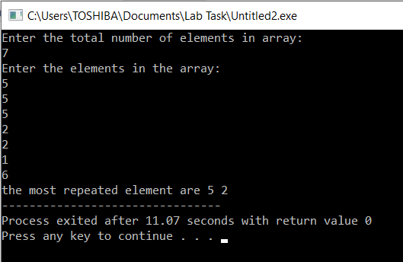 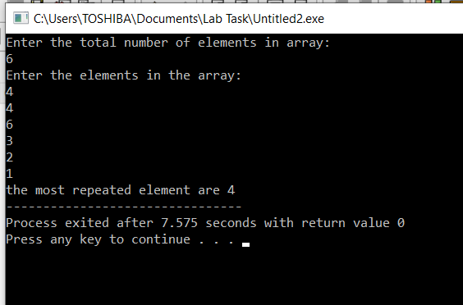

**TASK 2:**

Let’s say an array is a[8] = {13, 15, 17, 9, 99, 77, 65, 43}. Find largest and smallest element.

**Code**:

#include<bits/stdc++.h>

using namespace std;

int main(){

int arr[8]={13,15,17,9,99,77,65,43};

int min=0;

for(int i=1;i<8;i++){

if(arr[i]<arr[min]){

min=i;

} }

cout<<"minimum integer is : "<<arr[min]<<endl;

int max=0;

for(int i=0;i<8;i++){

if(arr[i]>arr[max]){

max=i;

} }

cout<<"maximum number is: "<<arr[max]<<endl;

return 0;

}

**Result:**

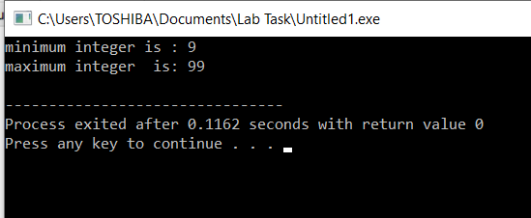

**Task 3:**

Develop a program that takes 5 array elements from user. Swap position [2] element with position [4] element. (Hint: Use the same method of swapping values we used for variables using a third variable temp).

**Code:**

#include<bits/stdc++.h>

using namespace std;

int main(){

int arr[5],temp;

cout<<"Enter the five integers: ";

for(int i=0;i<5;i++){

cin>>arr[i];

}

temp=arr[1];

arr[1]=arr[3];

arr[3]=temp;

cout<<"The new array is after swapping 2nd and forth position is: ";

for(int i=0;i<5;i++){

cout<<arr[i]<<" ";

}

return 0;

}

**Result:**

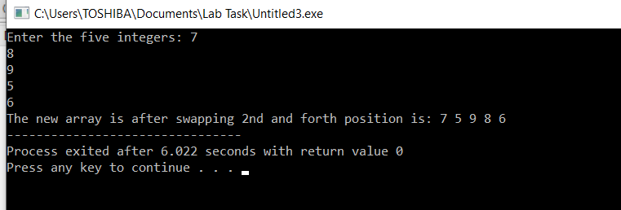

**The end**